Code Review

Program Being Reviewed: Sync/Deduplicate for Student 5

Reviewer: 2d Lt James Marvin

Date Reviewed:12 November 2018

Test Plan:
In my static analysis I will examine code for the following security sins:
Buffer Overruns
Format String Problems
Integer Overflows
Poor Usability
Exception Handling
Command Injection
In my test results section I will run the code and:
Test functionality/usability
Try to create errors based on the sins above

Static Analysis: Done before running the code
Buffer Overruns: -0 pts
The input is provided with command line arguments. The developer checked to see if the arguments were at least four (including the program name) but not over four. This shouldn’t matter because argv[4+] is not used in the code. The developer limits the size of the third and fourth arguments to 255 but does not place a numerical limit on the mode argument. From a buffer overrun perspective this should be ok because the developer is checking if the argument is equal to either “-s” or “-d”. I will check later in format command injection whether these conditions can evaluate to true with some malevolent input placed inside of them. I was concerned about the use of char* to contain the file inputs and arithmetic to calculate size, but the arithmetic within the mallocs seem sound. Based on my static analysis I found zero buffer overruns.

Format String problems: -0pts
All instances of printf appear to be safe because the user is never printing out the user input in them. I am still concerned about the user input being passed into the system command but that will be covered in command injection.

Integer Overflows: -0pts
Based on my static analysis there is potential for integer overflow when the developer uses malloc to allocate the size of the commands. The developer should avoid making allocation based on calculations. However, strlen() should always return a positive number when given the arguments from the command line because they are null terminated strings. It would be best practice to change the implementation, but not an error.

Usability: -0pts
The usage function will guide the user in use of proper arguments if they fail to do so. It also explains that the user can choose from. If they mess up the order of mode and files, the developer points it out to them. I don’t see any major usability problems from this static analysis.

Exception Handling: -5pts
There isn’t that much room for exceptions in this program, but there is one that is crucial to the program running correctly. The file paths are never checked to see if they are valid. The user input is merely passed to system command if they are less than 255 characters each. If they are not proper file paths an “ls” or “cp” command will not work as it is intended. I will cover this again in the command injection section. A possible solution would be using one of C’s file IO commands to check if the path is a directory.

Command Injection: -5pts
Passing user input to a system command is risky business. The user could place “|” in their supposed file path and execute an additional command. This could create an assortment of malevolent effects from deleting directories to executing commands as the super user. It is crucial that the developer implement a check on the file path inputs. A possible solution would be using one of C’s file IO commands to check if the path is a directory.

Test Results:
Functionality: Code runs and compiles +10pts, Sync works +30pts, Deduplicate works +30pts (all when given appropriate arguments)

Exception handling:
When given file paths “green” and “blue” (not valid paths) and the -d flag the code produced this output.
Dir1 Contents Before:
ls: cannot access blue: No such file or directory
Dir2 Contents Before:
ls: cannot access green: No such file or directory
---------------
ls: cannot access blue: no such file or directory
rm: cannot remove ‘error’: No such file or directory
Dir1 contents after:
ls: cannot access blue: No such file or directory
Dir2 contents after:
ls: cannot access green: No such file or directory
de-duplicate successful!
First, the code believes that it executed successfully even though the underlying commands failed out. Second, the errors revealed to the user some of the operations performed underneath including the “rm” system command. This is useful information to an attacker. They now know that if they pass the right directories and flags, they can delete important files. They also know that the user is using system commands and they can try command injection attacks.

Command injection:
My first trial with the following arguments -d "./dir1|rm -rf /" "./dir2|rm -rf ./dir1"
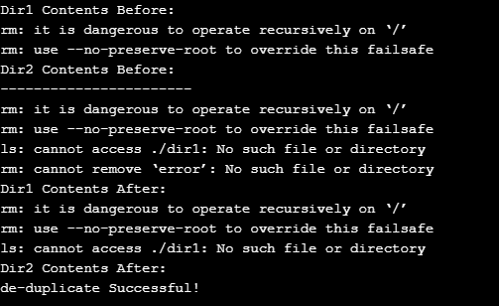
The OS protected against this delete root attack but the system commands printed out the flag I needed to overwrite this “—no-preserve-root”. However, I was able to delete dir1.
Second trial with the flag –no-preserve-root:
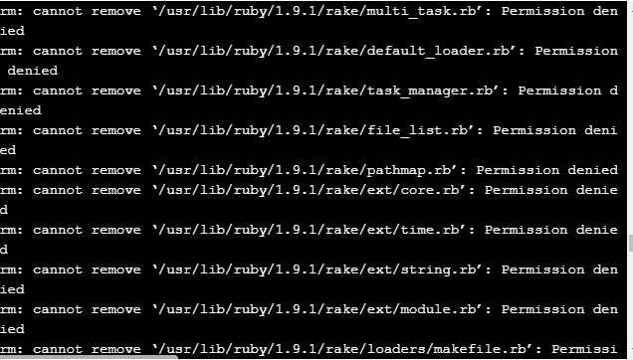
As you can see it tried to delete every file within the root directory. Thankfully most of the files had permission issues. But every file not protected by permissions would be deleted.

Additional Comments:
Overall this was a well written program, but there were two costly errors. Total score 60/70.

